**AYUB TEACHING HOSPITAL**

Department of Anaesthesia

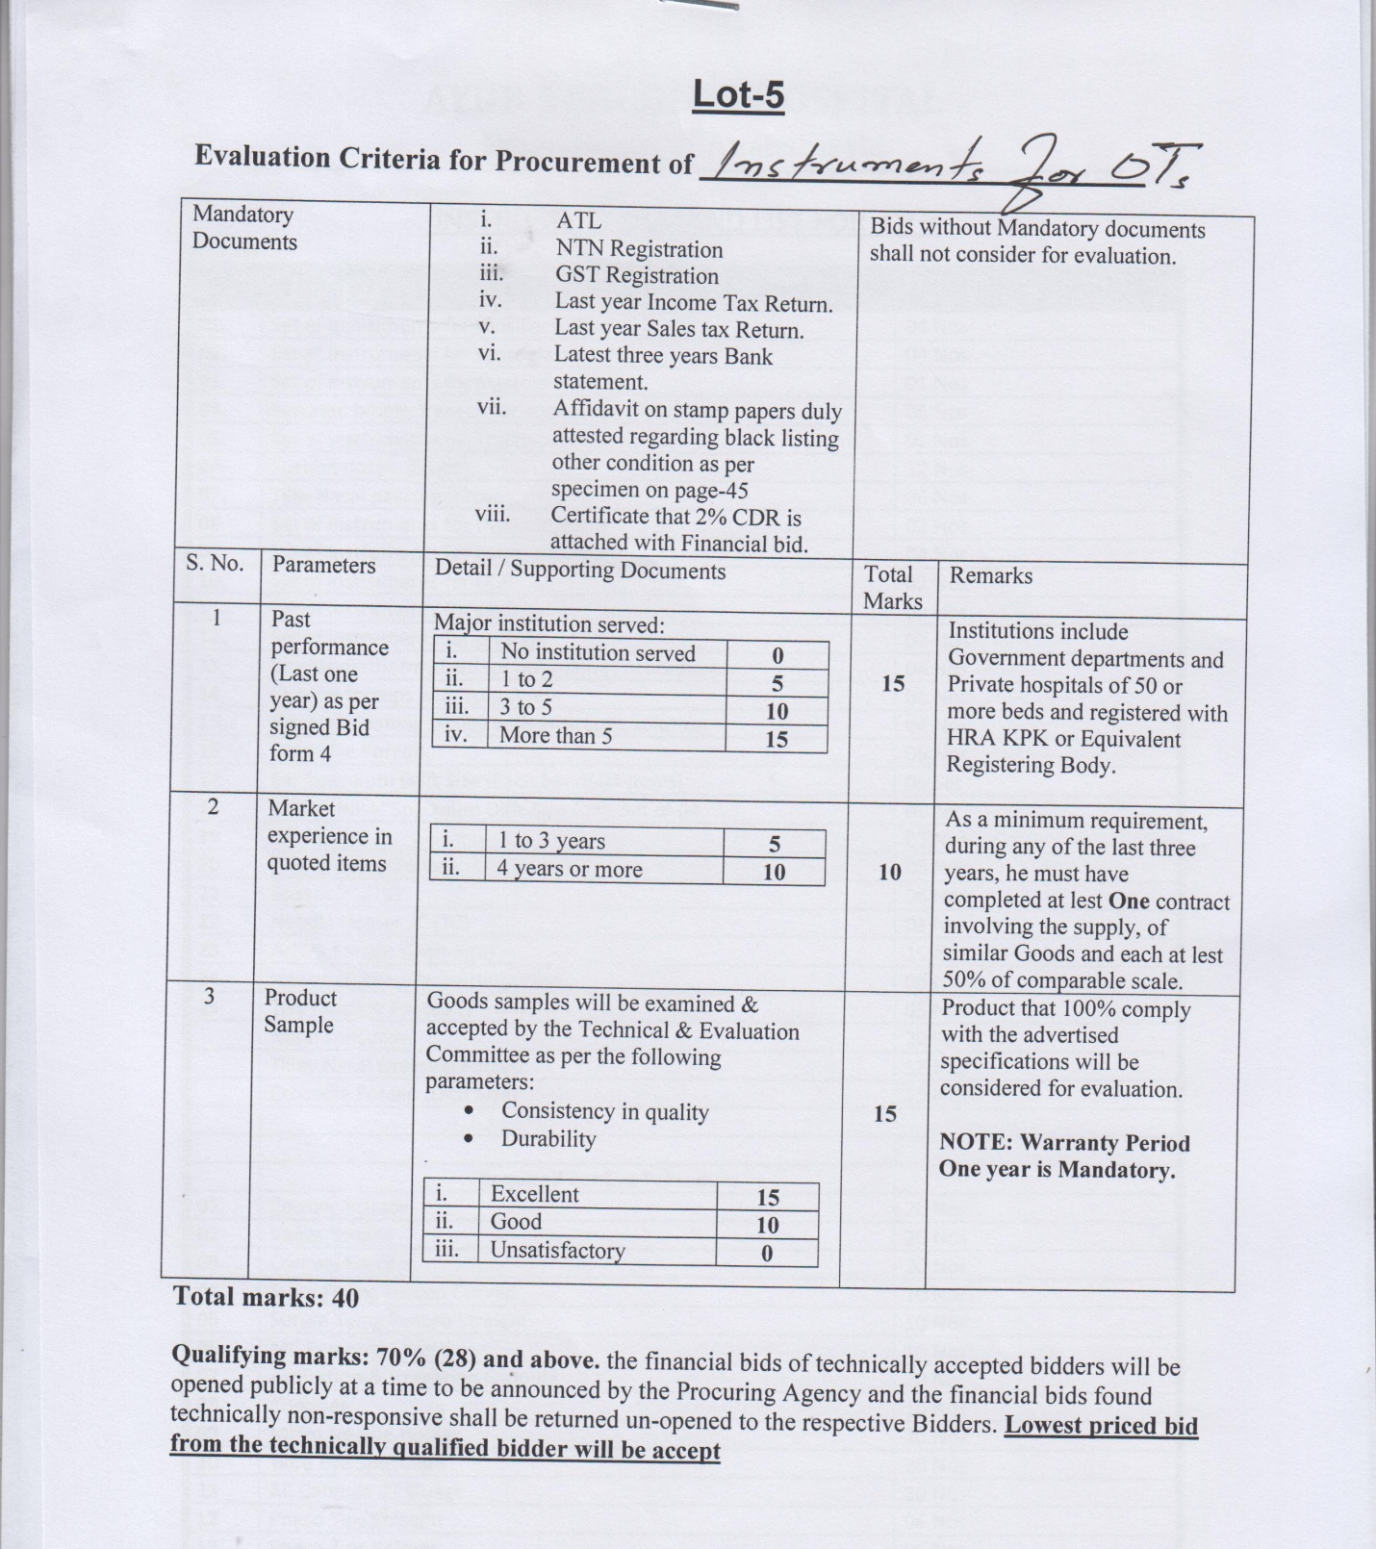 **INSTRUMENT DEMAND LIST FOR ALL OT`s**

**OT Block-A**

|  |  |  |
| --- | --- | --- |
| **S.NO** | **NAME** | **REQUIRED QTY** |
| **01.** | Set of instruments for tonsillectomy | 04 Nos |
| **02.** | Set of instruments for septoplasty | 04 Nos |
| **03.** | Set of instruments for mastoidectomy | 01 Nos |
| **04.** | Serrated biopsy forceps for endoscopy (Paed size) | 06 Nos |
| **05.** | Set of instruments for Tracheostomy | 01 Nos |
| **06.** | Suction nosals (Small) | 12 Nos |
| **07.** | Tillis Nasal packing forceps | 06 Nos |
| **08.** | Set of instruments for thyriodectomy | 02 Nos |
| **09.** | Set of instruments for cataracl Surgery | 04 Nos |
| **10.** | Set of instruments for DCR | 02 Nos |
| **11.** | Set of instruments for squinl | 02 Nos |
| **12.** | Set of instruments for probing | 02 NOs |
| **13.** | Bipolar diathermy lead for ophthalmic procedure | 04 Nos |
| **14.** | Cheetle forceps with containers | 06 Nos |
| **15.** | General cleaning trolley with antiseptic solution | 04 Nos |
| **16.** |  |  |

**OT Block-B**

|  |  |  |
| --- | --- | --- |
| **S.NO** | **NAME** | **REQUIRED QTY** |
| **01.** | Dressing drums (small , medium, large) | 09 each |
| **02.** | Rib cutter | 02 Nos |
| **03.** | Thyroid rectractor | 02 Nos |
| **04.** | Hamer (Medium , large) | 06 each |
| **05.** | Periosel elevator | 08 Nos |
| **06.** | Bone lever (Small, medium) | 10 Nos |
| **07.** | Bone cutter double action | 04 Nos |
| **08.** | Allies forceps medium | 60 Nos |
| **09.** | BP Handle (3” and 4” ) | 40 Nos |
| **10.** | Artery forceps (fine, tip, curved) small | 100 each |
| **11.** | Artery forceps (curved ) medium | 100 Nos |
| **12.** | Artery forceps (curved 8”) medium | 50 Nos |
| **13.** | Surgeon scissors (curved) | 50 Nos |
| **14.** | Assistant scissors (state 7 “) | 50 Nos |
| **15.** | Pneumatic drills | 02 Nos |
| **16.** | Pneumatic torniqit | 02 sets |
| **17.** | ILN set (tibia + femor) | 01 Nos |
| **18.** | Vernier celliper | 02 Nos |
| **19.** | Leg screw driver | 01 Nos |
| **20.** | Triple remor DHS | 01 Nos |
| **21.** | Triple remor DCS | 01 Nos |
| **22.** | Telo scope size “0” for laparoscopic surgery | 01 Nos |
| **23.** | Trocar canula (11 mm + 6 mm) | 08 each |
| **24.** | Grasping forceps (toothed + plain) | 04 each |
| **25.** | Mareland dissecting forceps | 02 Nos |
| **26.** | Harmonic shers (Lep) | 04 Nos |
| **27.** | Harmonic shers (open) | 04 Nos |
| **28.** | Bed mattress | 10 Nos |
| **29.** | Spica table | 01 Nos |
| **30.** | Led apron for C-arm | 12 Nos |

**OT Block-C (Gynae)**

|  |  |  |
| --- | --- | --- |
| **S.NO** | **NAME** | **REQUIRED QTY** |
| **01.** | BP Handle No.3 | 20 Nos |
| **02.** | BP Handle No. 4 | 20 Nos |
| **03.** | BP Handle No. 7 | 10 Nos |
| **04.** | Plan diecting forceps 8” | 20 Nos |
| **05.** | Plan diecting forceps 6” | 20 Nos |
| **06.** | Plan diecting forceps 4” | 20 Nos |
| **07.** | Needle Holder 8” | 30 Nos |
| **08.** | Needle Holder 6” | 20 Nos |
| **09.** | Needle Holder 4” | 20 Nos |
| **10.** | Surgeon Scissors (Fine) | 50 Nos (8”, 6”,4”) |
| **11.** | Surgeon Scissors (Mayo) | 20 Nos |
| **12.** | Assistant Scissors | 50 Nos (8”, 6”,4”) |
| **13.** | Small artery forceps cervical | 100 Nos |
| **14.** | Medium size artery forceps | 100 Nos |
| **15.** | Allies forceps | 50 Nos (8”, 6”,4”) |
| **16.** | Spong holders | 100 Nos |
| **17.** | Towal clamp | 200 Nos |
| **18.** | Hunny clamps curved | 50 Nos |
| **19.** | Cacicar forceps | 50 Nos |
| **20.** | Volsalum forceps | 20 Nos |
| **21.** | Ovem forceps (microgo spong) | 10 Nos |
| **22.** | Metallic catheter | 10 Nos |
| **23.** | Tomiculam forceps | 10 Nos |
| **24.** | Allies forceps | 05 Nos |

**C-OT (Casualty)**

|  |  |  |
| --- | --- | --- |
| **S.NO** | **NAME** | **REQUIRED QTY** |
| **01.** | Needle holders different size | 50 Nos |
| **02.** | Surgeon scissors | 50 Nos |
| **03.** | Danis brown | 10 Nos |
| **04.** | Bulldog clamp | 20 Nos |
| **05.** | Micro / Fine surgeon scissors | 10 Nos |
| **06.** | Small Mosquito artery forceps | 50 Nos |
| **07.** | Chetal forceps | 20 Nos |
| **08.** | Laheez forceps | 30 Nos |

**OT Block-D**

|  |  |  |
| --- | --- | --- |
| **S.NO** | **NAME** | **REQUIRED QTY** |
| **01.** | Steel Box 10”x14” | 03 Nos |
| **02.** | Karison ronger | 05 Nos |
| **03.** | Brain Needle | 12 Nos |
| **04.** | Dura Guide | 12 NOs |
| **05.** | Edssion brace | 06 Nos |
| **06.** | Pituitary forceps | 06 Nos |
| **07.** | Bone niblor (double) | 06 Nos |
| **08.** | Periostium elevator (Neuro Surgery) | 06 Nos |
| **09.** | Suction tip (different size 6,8,10,12) | 24 Nos |
| **10.** | Gigli saw hook | 12 Nos |
| **11.** | Brain retractor (Med, Small, Large) Neurosurgery | 06 set |
| **12.** | Needle Holder 6” | 24 Nos |
| **13.** | Needle Holder 8 “ | 24 Nos |
| **14.** | Allies forceps (long) | 18 Nos |
| **15.** | Laheys foreceps (Rt Angle) | 12 Nos |
| **16.** | Surgeon scissors (7”, 8”) | 36 Nos |
| **17.** | Sterilization drums (Extra large 03 / large 06) | 09 Nos |
| **18.** | Self retaining retractor (for kidney) | 03 Nos |
| **19.** | Rib cutter | 03 Nos |
| **20.** | Rib Elevator | 03 Nos |
| **21.** | Laheys forceps (Rt: angle) | 06 Nos |
| **22.** | Instruments trolleys | 06 Nos |
| **23.** | Mouth gauge with suspension rod + plate | 03 Set |
| **24.** | Michle stimmer | 03 pieces |
| **25.** | Bone file | 06 pieces |
| **26.** | Arcl bar (Erich) | 24 coils |

**DMS Article Store**

|  |  |
| --- | --- |
|  |  |