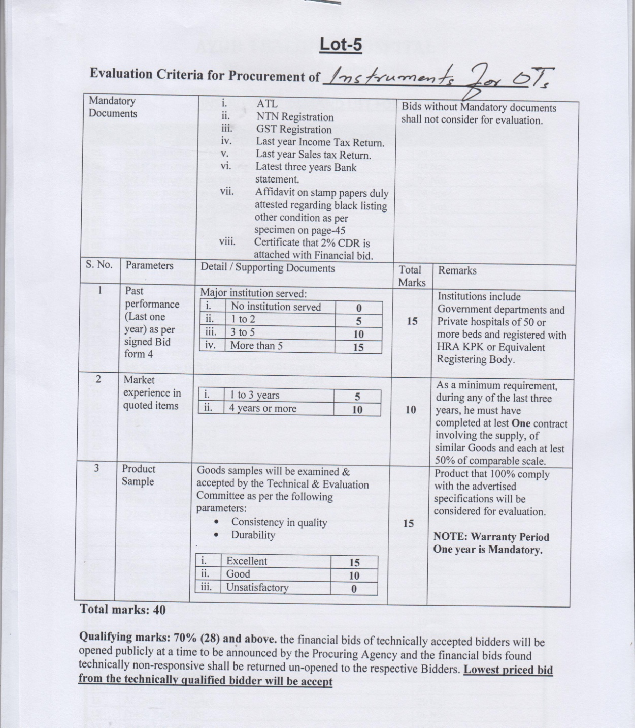

**DETAILED LIST OF THORACIC SURGERY INSTRUMENTS**

|  |  |  |  |  |
| --- | --- | --- | --- | --- |
| **S.No** | **Description** | **Quantity** |  |  |
|  | Foerster Sponge Forceps, 9-1/2" (24.1 cm), Curved, Serrated Jaw; EA | 02 |  |  |
|  | Foerster Sponge Forceps, 9-1/2" (24.1 cm), Straight, Serrated Jaw; EA | 02 |  |  |
|  | Backhaus Towel clamp 5-1/4” | 10 |  |  |
|  | Lanes tissue forceps 1x2 , 7” | 04 |  |  |
|  | Non-Perforating towel clamps | 04 |  |  |
|  | B.P. Knife handle for blade size 3, 6” long | 02 |  |  |
|  | B.P. Knife handle for blade size 4, 6” long | 02 |  |  |
|  | B.P. Knife handle for blade size 7, 6” long | 01 |  |  |
|  | B.P. Knife handle for blade size 7, 10” long | 01 |  |  |
|  | Plan tissue Forceps 10” | 02 |  |  |
|  | Dissecting Tissue Forceps plan 7” | 02 |  |  |
|  | Ferris-smith toothed tissue forceps 1x2 teeth 7” | 01 |  |  |
|  | Ferris-smith toothed tissue forceps 2x3 teeth 7” | 01 |  |  |
|  | Dissecting Tissue Forceps Waught fine tooth 8” | 02 | FDA |  |
|  | DeBakey Tissue Forceps 1.5 mm tip 8” | 02 | FDA |  |
|  | DeBakey Tissue Forceps 3.0 mm tip 8” | 02 | FDA |  |
|  | DeBakey Tissue Forceps 3.0 mm tip 12” | 02 | FDA |  |
|  | Insulated Touch Forceps 10” Straight Point | 02 |  |  |
|  | Cushing forceps bayonet shape serrated 7” | 02 |  |  |
|  | Adson tissue forceps, size 15cm | 01 |  |  |
|  | Adson tissue forceps toothed 1x2, size 15cm | 01 |  |  |
|  | Debakey Adson tissue forceps size 15cm | 02 | FDA |  |
|  | Mayo dissecting scissors curved Tc insert | 01 |  |  |
|  | Mayo dissecting scissors straight Tc insert | 01 |  |  |
|  | Metzenbeum Scissors 5” Tungsten Carbide curved | 02 |  |  |
|  | Metzenbeum Scissors 7” Tungsten Carbide curved fine | 02 | FDA |  |
|  | Metzenbeum Scissors 9” Tungsten Carbide curved | 02 |  |  |
|  | Metzenbeum Scissors 12” Tungsten Carbide curved | 01 |  |  |
|  | Supercut Scissors | 01 |  |  |
|  | Heavy Cutting Scissor | 01 |  |  |
|  | Satinsky vascular clamp small | 01 | FDA |  |
|  | Satinsky vascular clamp medium | 01 | FDA |  |
|  | Satinsky vascular clamp large | 02 | FDA |  |
|  | Debakey Satinsky Bulldog Clamp 2-3/4” Straight | 02 | FDA |  |
|  | Glover Bulldog Clamp 3-1/8” Straight | 02 | FDA |  |
|  | Glover Bulldog Clamp 4-1/8” Straight | 02 | FDA |  |
|  | Debakey tissue and organ grasping forceps 10” | 02 | FDA |  |
|  | Debakey multipurpose clamp obtuse angle 600 12” long, 10cm jaw | 02 | FDA |  |
|  | Farabeuf Raspatory light curved sharp 15cm | 02 |  |  |
|  | Doyen Raspotries 6-3/4” Left | 01 |  |  |
|  | Doyen Raspotries 6-3/4” Right | 01 |  |  |
|  | Semb Rib Raspatories(periostium elevator) | 01 |  |  |
|  | Stille Giertz Rib Shear D/Action 10” (rib cutter) | 02 |  |  |
|  | Stille leur bone rongeur 8-3/4” | 01 |  |  |
|  | Stille leur duckbill bone rongeur 8-3/4” 3mm bite | 01 |  |  |
|  | Stille leur duckbill bone rongeur 8-3/4” 8mm bite | 01 |  |  |
|  | Freer Periosteal Elevator Double Ended - 220mm - 8.66 | 01 |  |  |
|  | Price Thomas -First Rib Raspatory | 01 |  |  |
|  | Heavy periosteum elevator 450 angled | 02 |  |  |
|  | Up-cut no 3 | 02 |  |  |
|  | Lawrence forceps curved with longitudinal serrations 10.75” | 02 | FDA |  |
|  | Gemini Thoracic Forceps Acutely Curved Jaws 11” | 02 | FDA |  |
|  | Mixture Thoracic Forceps 9” | 01 | FDA |  |
|  | Lahey dissecting forceps 8” | 01 | FDA |  |
|  | Lahey dissecting forceps 10” | 01 | FDA |  |
|  | Lahey dissecting forceps 12” | 01 | FDA |  |
|  | DeBakey Thoracic dissecting Forceps narrow C curve (45o) 8” | 01 | FDA |  |
|  | DeBakey Thoracic dissecting Forceps narrow C curve (45o) 10-3/4” | 01 | FDA |  |
|  | Halsted mosqueto artery forceps curved 5” | 06 |  |  |
|  | Kelly artery forceps curved 5.5” | 06 |  |  |
|  | Kelly artery forceps straight 5.5” | 04 |  |  |
|  | Coller artery forceps curved 6.5” | 04 |  |  |
|  | Rochester-Pean forceps curved 8” | 06 |  |  |
|  | Roberts Artery Forceps large Size | 08 |  |  |
|  | Kocher (Roch-Oschner) forceps straight 1x2 6” | 02 |  |  |
|  | Kocher (Roch-Oschner) forceps straight 1x2 8” | 02 |  |  |
|  | DeBakey Kelly artery forceps curved 5.5” | 04 | FDA |  |
|  | Duval Lung Grasping Forceps 1” Jaws 8” | 02 | FDA |  |
|  | Duval Lung Grasping Forceps 1” Jaws 9-1/2” | 02 | FDA |  |
|  | Mayo Hegar Needle Holder Tc insert 6” | 02 | FDA |  |
|  | Mayo Hegar Needle Holder Tc insert 8” | 02 | FDA |  |
|  | Mayo Hegar Needle Holder Tc insert 10.5” | 02 | FDA |  |
|  | Mayo Hegar Needle Holder Tc insert 12” | 01 | FDA |  |
|  | Ryder Needle Holder Tungsten Carbide tip 7” fine | 01 | FDA |  |
|  | Ryder Needle Holder Tungsten Carbide tip 10.5” fine | 01 | FDA |  |
|  | New Orleans Needle Holder Tungsten Carbide tip 8” | 01 | FDA |  |
|  | Castroviejo needle holder with lock serrated jaws Tc insert 7” | 01 | FDA |  |
|  | Mayo Rabonsen Intestinal Clamp (Non Crushing) | 04 | FDA |  |
|  | Derra Anastomosis Clamp DeBakey various sizes | 06 |  |  |
|  | Finochieto Rib Spreader infant size | 02 | FDA |  |
|  | Finochieto Rib Spreader child size | 02 | FDA |  |
|  | Finochieto Rib Spreader adult size medium standard | 02 | FDA |  |
|  | Finochieto Rib Spreader adult size medium heavy duty | 02 | FDA |  |
|  | Finochieto Rib Spreader adult size large | 02 | FDA |  |
|  | DeBakey sternum spreader small | 01 |  |  |
|  | DeBakey sternum spreader medium | 01 |  |  |
|  | DeBakey sternum spreader large | 01 |  |  |
|  | Allison Lung Spatula wire made infant size | 01 |  |  |
|  | Allison Lung Spatula wire made child size | 01 |  |  |
|  | Allison Lung Spatula wire made adult size small | 01 |  |  |
|  | Allison Lung Spatula wire made adult size large | 01 |  |  |
|  | Davidson Scapula Retractor | 01 |  |  |
|  | Tudor Edwards Scapula Retractor | 01 |  |  |
|  | Weitlaner retractor solid blades 5-1/2” | 02 |  |  |
|  | Langenbeck Retractor small | 02 |  |  |
|  | Langenbeck Retractor medium | 02 |  |  |
|  | Morris Retractor 2”x2”x9” | 02 |  |  |
|  | Morris Retractor 2”x3”x9” | 02 |  |  |
|  | Deever Retractor 1”x12” | 02 |  |  |
|  | Deever Retractor 2”x12” | 02 |  |  |
|  | Babcock Forceps 6” | 03 |  |  |
|  | Babcock Forceps 8” | 03 |  |  |
|  | Babcock Forceps 10” | 03 |  |  |
|  | Allis Tissue Forceps 4x5 size 6” | 02 |  |  |
|  | Allis Tissue Forceps 5x6 size 8” | 02 |  |  |
|  | Allis Tissue Forceps 5x6 size 10” | 02 |  |  |
|  | Wire Twister 8” | 01 |  |  |
|  | Williger Mallet 30mm dia 400 gm(Hammer) | 01 |  |  |
|  | Lebsche Sternal Chesil 10” | 01 |  |  |
|  | Maleable Spatula copper 1-1/2 “x 12” | 01 |  |  |
|  | Reverdin Abdominal Spatula 285 MM 285 mm, 11.25, 63 mm, 45 mm | 01 |  |  |
|  | Bailey rib contractor | 01 |  |  |
|  | Martin dermal Curette 5.5” 4mm & 5mm oval cups | 01 |  |  |
|  | Poole Suction Tube Perforated End 14” stainless steel 30Fr | 02 |  |  |
|  | Yankauer (SUM) Suction Tube | 02 |  |  |
|  | Bowel stainless steel 4” | 02 |  |  |
|  | Bowel stainless steel 5” | 02 |  |  |
|  | Kidney tray 8” | 02 |  |  |
|  | Kidney tray 10” | 02 |  |  |
|  | Basin solution deep (unicef pattern) 6 litre capacity | 01 |  |  |
|  | Foss tube milking forceps | 02 |  |  |
|  | Instruments box perforated with case basket large size | 01 |  |  |
|  | Instruments box perforated with case basket small size | 02 |  |  |
|  | Liga-Clip applicator for medium large clips 10x360mm | 02 | FDA |  |
|  | Liga-Clip applicator for large clips 10x360mm | 02 | FDA |  |
|  | Hem-o-lok clip applicator for medium large clips 10x330mm | 02 | FDA |  |
|  | Hem-o-lok clip applicator for large clips 10x330mm | 02 | FDA |  |
|  | Operating loops 2.5x | 01 | FDA |  |
|  | Operating loops 3.5x | 01 | FDA |  |