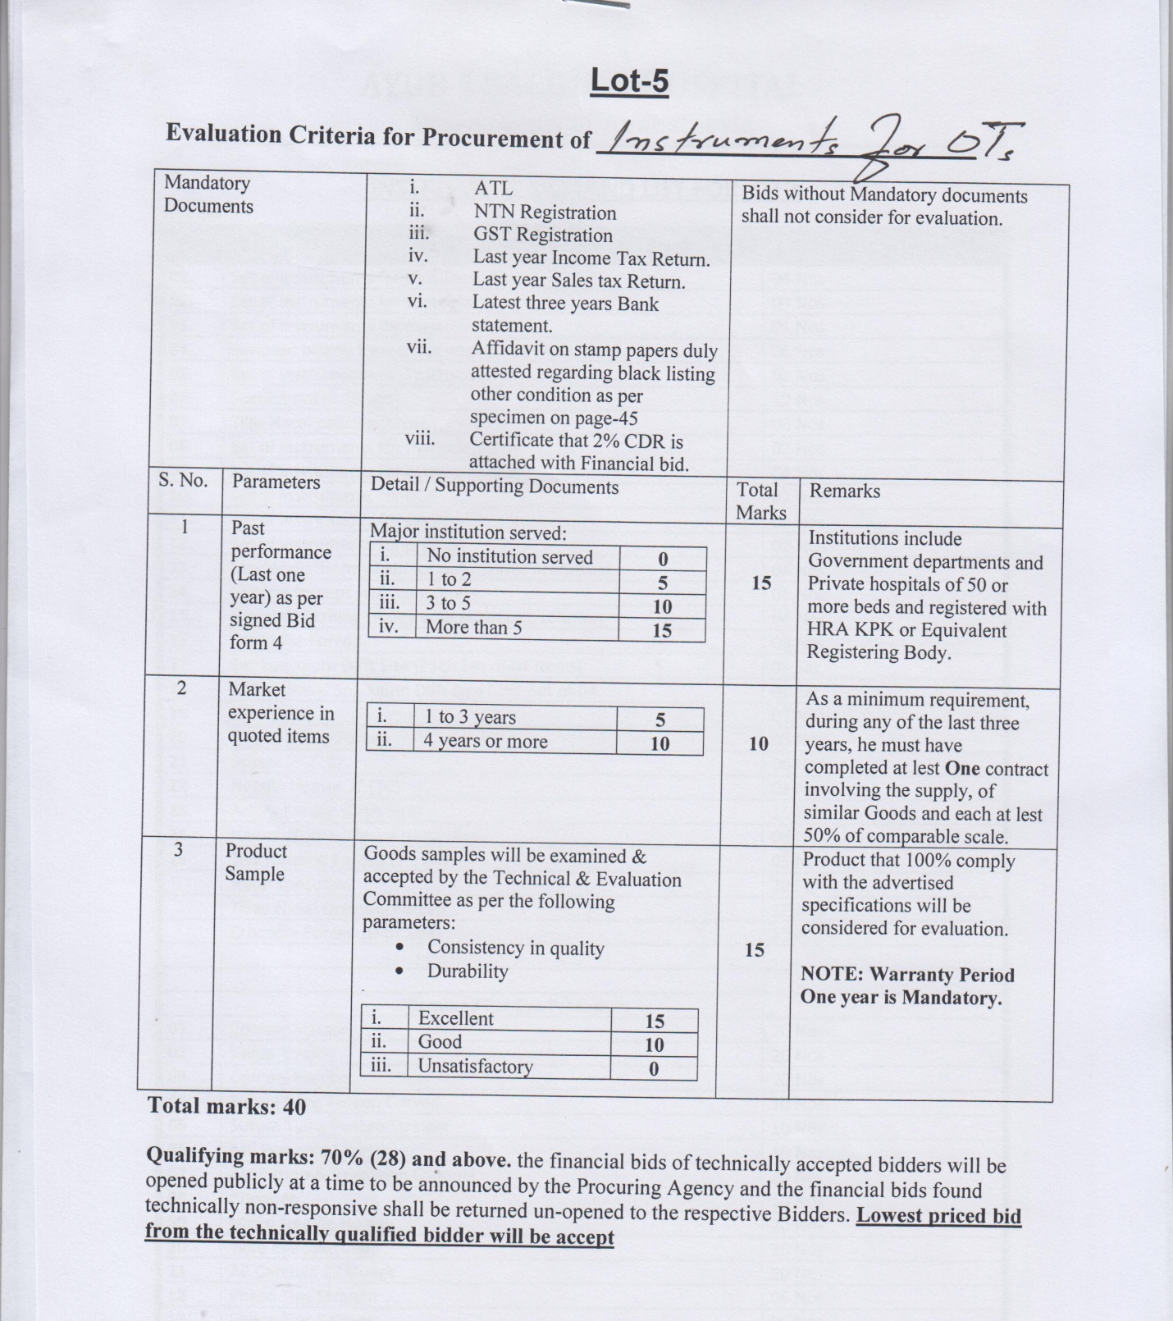
List of Instruments Required for Ortho ward.
S.No | Description | QTY
 | Basic Instruments Set Orthopedic | 01 Set
 | DCP (Plating Set) Large fragmet | 01 Set
 | DCP (Plating Set) Small Fragmet | 01 Set
 | Interlocking Nailing Set (Femur with assembly & pneumatic reamers) | 01 Set
 | Interlocking Nailing Set ( with Tibia assembly & pneumatic reamers) | 01 set
 | DHS Set | 01 Set
 | DCS Set | 01 Set
 | Spinal Instrumentation Set | 01 Set
 | Bone Grafting Set (graft harvest) | 01 Set
 | Partial HIP replacement Set including charnely retractor | 01 Set
 | POP Cutter | 01 No
 | Brawn Frame | 10 Nos
 | Artery Forcep | 05 Nos
 | Dressing Drum Small | 05 Nos
 | Knife Holder | 02 Nos
 | Moris Retractor | 01 No
 | Kidney Tray 10” | 02 Nos
 | Kidney Tray 8” | 05 Nos
 | Kidney Tray 6” | 01 No
 | Needle Holder | 02 Nos
 | Tooth/Plain Forcep | 08 Nos
 | Plaster Tray | 01 No
 | Surgical Assistant Scissor | 02 Nos

